**Our business**

**Our business : ZONE 1 Feed industry**

**Poultry industry**

- We have our poultry research center to create knowledges for improving skills.

- We have created the model to succeed with broiler integrated farm.

- We have specialist major in poultry nutrition, farm management, meat and eggs quality that can improve the value of business.

- We are top 3 in pigment solutions for layers production

**Swine industry**

- We have good relationship with farm partners that can study how to use the product for reference in formation.

- We have team and sub-distributor to fullfill all segments of swine business.

- We have an experience in swine production that can enhancer growth performance, carcass, and meat quality from farm to

slaughterhouse.

- We are the one player who focus on carcass and meat quality improvement and value added.

**Dairy and beef industry**

- We have experted team who research in cattle farm.

- We have an experience in dairy cattle more than 20 years.

- We have good relationship with potential customers and dairy co-operation.

- Our team can support beef industry to improve carcass and meat quality from feed to meal.

**Aquaculture industry**

- We are collaboration with our partner, customers and researcher to develop innovation for aquaculture industry.

- We have opportunity to develop our knowledges with specialist of aquaculture production.

- We are 1st natural pigment market share in aquaculture.

- Our team is created how to apply the product that can improve the benefit for customers.

- We always improve our skills and relationships in aquaculture field.

**Pet food industry**

- Bio Shine has participated in PIA member since 2018.

- Promoted palatability enhancer in pet food since 2004.

- Excellent relationship with petfood industry more than 18 years.

**Our business : ZONE 2 Food industry**

**Food supplement**

Collagen :

- Atom amino Collagen   
 - OK Collagen tripeptides

- Bio pure Collagen tripeptides  
 Natural product :

- Bio pure organic spirulina

- Bio Turma

**Branding creation and OEM product**

- Supply raw material

- Product development : Basic formular   
 : Special formular

- Product registration

- Manufacturing : created packaging ใส่รูปตัวอย่างสินค้า OEM เช่น Pet marin และ LV Protect





**Our Product : ZONE 1. Plant extract**

**แนบรูปใน file one page สามารถ โหลดได้ในแต่ละสินค้าที่มีไฟล์**

**Product name : AV 3**

Product description : Oxidative balance promotor

Benefits : - Promotes the biological antioxidant in the animals.

- Specific herbal extracts to conductive an antioxidant and anti-inflammatory effect.

- Helps strengthen the immune system

- Supports immunity under stress conditions

- Reduces mortality rate

- Reduces rearing and weaning losses

- Faster recovery from illness

- Stimulation of the estrus and reduction of returning to heat

Animals : สัตว์ปีก หมู วัว แพะ กุ้ง ปลา สุนัข แมว

Origin : France

**Product name : Emanox**

Product description : Anticoccidial

Benefits : - Antiparasitic action for enhanced performances

- A better control of risks linked to intestinal parasites and maintaining intestinal balance.

- Its potent anticoccidial effect against internal parasites as well as for its anti-inflammatory   
 action.

- It exhibits anti-inflammatory properties to protect from injuries induced by parasites.

- Reduce risk of constipation and diarrhea

- Replacement coccidiostat

Animals : สัตว์ปีก หมู วัว แพะ กุ้ง ปลา

Origin : France

**Product name : Kerlait**

Product description : Antibacterial

Benefits : - Control of the risks linked to Bacteria.

- Reduces the bacterial contamination.

- Reduces the risk of salmonella and E. coli

- Improves the digestion.

- A better management of bacterial contamination and improving digestion.

Animals :สัตว์ปีก หมู วัว แพะ กุ้ง ปลา

Origin : France

**Product name : Prodol B / Prodol liquid TH5**

Product description : Anticoccidial and Antibacterial (Powder / liquid)

Benefits : - Antiparasitic and antibacterial for enhanced performances.

- A better management of protozoa and bacterial contamination to improve digestive   
 system and gut health.

- Anticoccidial and internal parasites to directly kill infective sporozoites

- It’s anti-inflammatory action to protect the host tissue

Animals :สัตว์ปีก หมู วัว แพะ กุ้ง ปลา

Origin : France

**Product name : Silagreen / Flavotan**

Product description : Improves silage quality (Powder / Liquid)

Benefits : - Enhances quality of silage : grass and corn silage  
 - Improves prebiotic function to produce good bacterial (probiotic)   
 - Improves milk yield and milk quality  
 - Improves volatile fatty acids

Animals : โคเนื้อ โคนม แพะ

Origin : France

**Product name : Fan+F4**

Product description : Appetite Stimulants (Powder / Liquid)

Benefits : - Stimulates the appetite and improves feed intake  
 - Enhances carcass quality

- Improves lean percentage

- Enhances fat and lean ratio   
 - Laying performances are improved  
 - Increases milk yield

Animals : สัตว์ปีก หมู วัว แพะ โคเนื้อ โคนม สุนัข แมว

Origin : France

**Product name : Red protect**

Product description : Anti-external Parasites

Benefits : - Control and Management of External Parasites  
 - Herb extract such as thyme and lemongrass for a better management of livestock buildings hygiene

Animals : สัตว์ปีก

Origin : France

**Product name : KIG**

Product description : Anti-external Parasites

Benefits : - Control and Management of External Parasites  
 - Herb extract such as Geraniol to contributed to a better management of external parasite for aquatic animal

Animals : ปลา

Origin : France

**Product name : KOD / KOD ATM**

Product description : Regulation of Stress / Feed Behavior

Benefits : - Increased levels of stress are not only detrimental for the animal welfare but also cause important financial losses.

- Making easier the handling of animals

- Enhancement of the global stress conditions

- Decreases of the tail-biting

- Reduces the animal aggressive behaviour

- Enhances carcass and meat quality : Catching time and transportation time

Animals : สัตว์ปีก หมู วัว แพะ กุ้ง ปลา หมา แมว

Origin : France

**Our Product : ZONE 2. Natural Antioxidant Fixed menu bar**

**แนบรูปใน file one page สามารถ โหลดได้ในแต่ละสินค้าที่มีไฟล์**

**Product name : Arresto Liquithox**

Product description : Alternative natural antioxidant

Benefits : - To replace ethoxyquin in all oil-based products

- An oil-based antioxidant used to protect fish oils

- Enhances shelf-life of fish meal and feed

Animals : ปลาป่น น้ำมันปลา ปลา กุ้ง หมู ไก่

Origin : England

**Product name : Arresto Rethox**

Product description : Alternative natural antioxidant

Benefits : - It has a higher antioxidant capacity than BHT and 66% Ethoxyquin powder.

- To replaced ethoxyquin and BHT powder

- The powder antioxidant used to protect fishmeal and feed

Animals : ปลาป่น ปลา กุ้ง หมู ไก่

Origin : England

**Product name : Arresto Acidox**

Product description : Alternative natural antioxidant

Benefits : - It can use Arresto Acidox options in replacing synthetic antioxidants in feed   
 formulation.

- Arresto Acidox is natural antioxidant for protection raw material, fish meal, and   
 feed from oxidation.

Animals : ปลาป่น ปลา กุ้ง อาหารสัตว์

Origin : England

**Product name : Arresto 1.5 Conc.**

Product description : Alternative natural antioxidant

Benefits : - Natural alternative antioxidant for concentrate BHT&BHA blend

- Primary function is protected feed from oxidation, rancid and improves growth   
 performance and lower FCR.

Animals : ปลาป่น ปลา กุ้ง อาหารสัตว์ สุนัข แมว

Origin : England

**Product name : Oxabiol Premium**

Product description : Natural mixed tocopherol (Powder / Liquid)

Benefits : - Feed preservatives and enhances shelf-life of products

- Stable at high temperatures

- Does not alter product palatability

Animals : ไก่ วัว หมู สุนัข แมว ปลา กุ้ง

Origin : Spain

**Product name : Oxabiol blends**

Product description : Natural mixed tocopherol with plant extract (Powder / liquid)

Benefits : - Feed preservatives and enhances shelf-life of products

- Stable at high temperatures

- Does not alter product palatability

- Protects lipid compounds from oxidation

Animals : ไก่ วัว หมู สุนัข แมว ปลา กุ้ง

Origin : Spain

**Our Product : ZONE 3. Pigment**

**แนบรูปใน file one page สามารถ โหลดได้ในแต่ละสินค้าที่มีไฟล์**

**Product name : BS Leader yellow 2%**

Product description : Natural Yellow Pigment (Powder / liquid)

Benefits : - Source of natural yellow pigment from Marigold extract.

- Improves egg yolk and skin color.

- Improves shrimp color and catfish skin.

- It’s antioxidant action to protect the free radicals.

Animals : ไก่ไข่ เป็ด ไก่เนื้อ กุ้ง ปลา

Origin :China

**Product name : BS Leader red 1%**

Product description : Natural Red Pigment (Powder / liquid)

Benefits : - Source of natural yellow pigment from Marigold extract.

- Improves egg yolk and skin color.

- Improves shrimp color and catfish skin.

- It’s antioxidant action to protect the free radicals.

Animals : ไก่ไข่ เป็ด ไก่เนื้อ กุ้ง ปลา

Origin :China

**Product name : Leader Golden 50 EXT**

Product description : Natural Yellow Pigment

Benefits : - Source of natural yellow pigment from Marigold extract.

- Improves egg yolk and skin color.

- Enrich of natural zeaxanthin.

- Improves shrimp and fish color.

Animals : ไก่ไข่ เป็ด ไก่เนื้อ กุ้ง ปลา

Origin :China

**Product name : Leader Pink 100 EXT**

Product description : Synthetic Pigment (Powder / liquid)

Benefits : - Synthetic astaxanthin

- Improves color of shrimp and fish

- It can improve survival rate, reproductive and performance.

Animals : กุ้ง ปลา

Origin :China

**Product name : Leader Red 100 EXT**

Product description : Synthetic Pigment (Powder / liquid)

Benefits : - Synthetic canthaxanthin

- Improves egg yolk color.

- Improves shrimp and fish color.

Animals : ไก่ไข่ เป็ด ไก่เนื้อ กุ้ง ปลา

Origin : China

**Our Product : ZONE 4. Immune Stimulant and Yeast extract**

**แนบรูปใน file one page สามารถ โหลดได้ในแต่ละสินค้าที่มีไฟล์**

**Product name : Biolex MB 40**

Product description : Immune Stimulant

Benefits :

- Biolex MB40 is a brewers’ yeast cell wall product rich in (1,3)-(1,6)-ß-D-glucans and mannans (MOS)

* Supports and relieves the immune system
* Prebiotic effect and strongly promotes beneficial and inhibits potentially pathogenic bacteria in the gut.
* Supports and relieves the immune system
* Leads to improvements in gut morphology and gut-associated lymphoid tissue.
* Forms an additional protective infection barrier / biofilm on the gut mucosa
* Addition effect from mycotoxin binding effect from Mannan oligo saccharides

Animals : สัตว์ปีก หมู วัว แพะ สุนัข แมว ปลา กุ้ง

Origin : Germany

**Product name : Beta S**

Product description : Prebiotic and Immune Stimulant

Benefits :

- Highly purified 1,3-1,6-ß-D-glucans from 100 % brewer‘s yeast

* Improves non-specific cellular & humoral immunity
* Increases survival rates during infections
* Pronounced adjuvant effect in vaccinations
* Improves growth performance
* Overall a great tool to boost the immune system of aquatic animals and to prophylactically prepare them against occurring diseases

Animals : สัตว์ปีก หมู วัว แพะ สุนัข แมว ปลา กุ้ง

Origin : Germany

**Product name : Cefi Pro**

Product description : Yeast Autolysate (hydrolysed)

Benefits : - Provide high levels and high bioavailable nutrients and nucleotides

* Promotes cell division, regeneration and repair through nucleotides
* Increases growth performance and feed conversion
* Also achieves gut-health promoting effects through both nucleotides & yeast cell walls
* Strong bacteriostatic effect against antibiotic resistant bacteria due to important hop constituents.

Animals : สัตว์ปีก หมู วัว แพะ ปลา กุ้ง

Origin : Germany

**Product name : Leiber YeaFi**

Product description : : Yeast Autolysate (hydrolysed)

Benefits : - Brewers ́yeast with the power of fiber

- Improves gut morphology in animals (higher intestinal villi)

- Reduces rearing and weaning losses

- Reduces the incidence of diarrhea due to a high-water binding capacity in the gastrointestinal tract

- Enhances metabolism imbalances

- High quality supply of B-vitamins

- Stimulation of the estrus and reduction of returning to heat

Animals : สัตว์ปีก หมู วัว แพะ สุนัข แมว ปลา กุ้ง

Origin : Germany

**Our Product : ZONE 5. Spirulina and Algae**

**แนบรูปใน file one page สามารถ โหลดได้ในแต่ละสินค้าที่มีไฟล์**

**Product name : Biomega-Tech® HA**

Product description : DHA source

Benefits : - It is a seaweed flour (*Schizochytrium* sp.) rich in Omega 3 fatty acids (DHA).

- It is the best vegetable alternative to fish oils due to its high content of DHA.

- Improves shrimp hatchery rate

- Helps strengthen the immune system

- Promotes healthy and shiny coat

Animals : สุนัข แมว ปลา กุ้ง

Origin : Spain

**Product name : Spirulina**

Product description : Protein & phycocyanin source and multifunction nutrients

Benefits : - Spirulina is natural micro algae for enhance immune system

- Improvements in growth performance and feed conversion

- Enrich of amino acids, protein and phycocyanin source

- To increase survival rates

Animals : สัตว์ปีก หมู วัว สุนัข แมว ปลา กุ้ง

Origin : China

**Our Product : ZONE 6. Palatability enhancer and Attractant**

**แนบรูปใน file one page สามารถ โหลดได้ในแต่ละสินค้าที่มีไฟล์**

**Product name : Antenna**

Product description : Attractant

Benefits : - Natural identical metabolite from Phytoplankton and Marine algae

- Strong attractant and palatability enhancer for aquatic feed, increase feed intake

- Stimulate feed biting frequency and reduce wastage of feed and water pollution

- Promotes larval development (high growth)

- Molting enhancer for crustaceans

Animals : ปลา กุ้ง

Origin : China

**Product name : Nutaste ® Profile**

Product description : Palatability enhancer (Brewers’ yeast extracts)

Benefits : -Different taste profiles with a wide range of applications

-Palatability contributor with high umami notes

-High in natural glutamic acid

-Ideal for low salt formulations

-Enhance meat flavour and provide full-rounded flavour in mouth

-Relevant for vegetarian and vegan applications

Animals : สุนัข แมว

Origin : Germany

**Product name : Nutaste ® Function**

Product description : Palatability enhancer (Autolysed brewers’ yeast)

Benefits : - Palatability-enhancing effect : high natural contents of free amino acids, glutamic acid and nucleotides.

- It contains the entire brewers’ yeast cell, components within the cell and from the cell wall.

- Increases the first bite in dry kibbles for dogs.   
 - NuTaste® function increased the palatability in dry kibbles for dogs.

well-balanced umami effect

no bitter-metallic taste despite KCl content

Animals : สุนัข แมว

Origin : Germany

**Our Product : ZONE 7. Mycotoxin Binder**

**แนบรูปใน file one page สามารถ โหลดได้ในแต่ละสินค้าที่มีไฟล์**

**Product name : Detoxizyme**

Product description : Mycotoxin binder

Benefits : - Reduce mycotoxin contamination

- Complete mycotoxin control for protecting animal health by effective against wide range of mycotoxins

- Improves the laying and broiler performance

- Reduces shell breakage and soft-shelled eggs

Animals : สัตว์ปีก หมู วัว แพะ ปลา กุ้ง

Origin : India

**Product name : Detoxizyme Conc.**

Product description : Concentrated Mycotoxin binder

Benefits : - Reduce mycotoxin contamination

- Complete mycotoxin control for protecting animal health by effective against wide range of mycotoxins

- Improves the laying and broiler performance

- Reduces shell breakage and soft-shelled eggs

Animals : สัตว์ปีก หมู วัว แพะ ปลา กุ้ง

Origin : India

**Our Product : ZONE 8. Emulsifier**

**แนบรูปใน file one page สามารถ โหลดได้ในแต่ละสินค้าที่มีไฟล์**

**Product name : Liposorb P**

Product description : Emulsifier and improve lipid utilization

Benefits : - Blend of Phosphatidyl Choline (PC), Lysophosphatidyl Choline (LPC) and Polyethylene Glycol Ricinolate (PEGR)

- Energy reduction in feed formulation

- Improves animal performance

- Enhances Feed mill efficiency

- Increases feed quality (PDI and Hardness)

- Reduces electricity consumption

Animals : สัตว์ปีก หมู วัว แพะ ปลา กุ้ง

Origin : India

**Product name : Liposorb DS**

Product description : Emulsifier and improve lipid utilization

Benefits : - Blend of Phosphatidyl Choline (PC), Lysophosphatidyl Choline (LPC) help in emulsification and further formulation of smaller compact micelles for better lipid digestion and absorption.

- Improves animal performance

- Increases feed quality (PDI and Hardness)

Animals : สัตว์ปีก หมู วัว แพะ ปลา กุ้ง

Origin : India

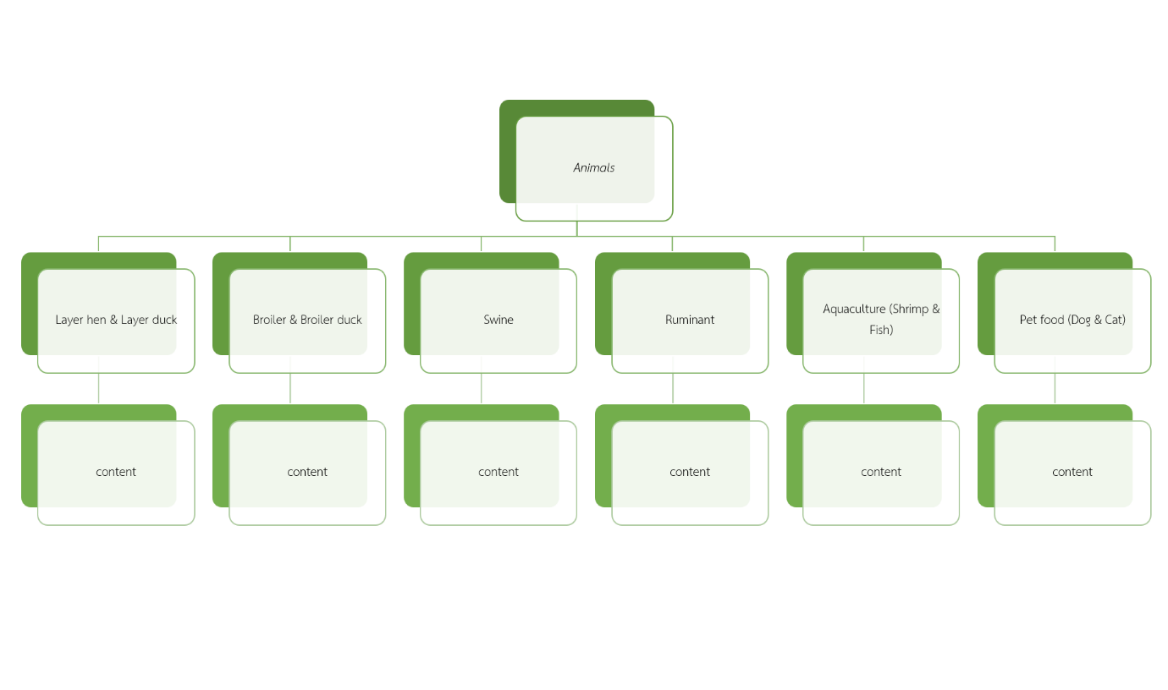

**Our Product : Animal 1. Layer hen & Layer duck   
Fixed menu bar เพื่อเวลาอยากเปลี่ยน topic ก็ได้ไม่ต้องเลื่อนย้อนมาไกล**

**--> ใช้ข้อมูลสินค้าชุดเดียวกับ product category**  
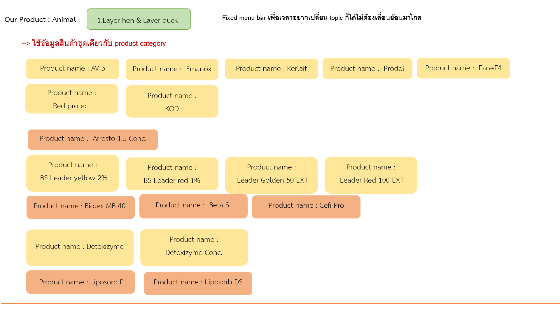

**AV 3**

**Emanox**

**Kerlait**

**Prodol**

**Fan+F4**

**Red protect**

**KOD**

Arresto 1.5 Conc.

**BS Leader yellow 2%**

**BS Leader red 1%**

**Leader Golden 50 EXT**

**Leader Red 100 EXT**

Biolex MB 40

Beta S

Cefi Pro

**Detoxizyme**

**Detoxizyme Conc.**

Liposorb P

Liposorb DS

**Our Product : Animal 2. Broiler & Broiler duck**

**Fixed menu bar เพื่อเวลาอยากเปลี่ยน topic ก็ได้ไม่ต้องเลื่อนย้อนมาไกล**

**--> ใช้ข้อมูลสินค้าชุดเดียวกับ product category**

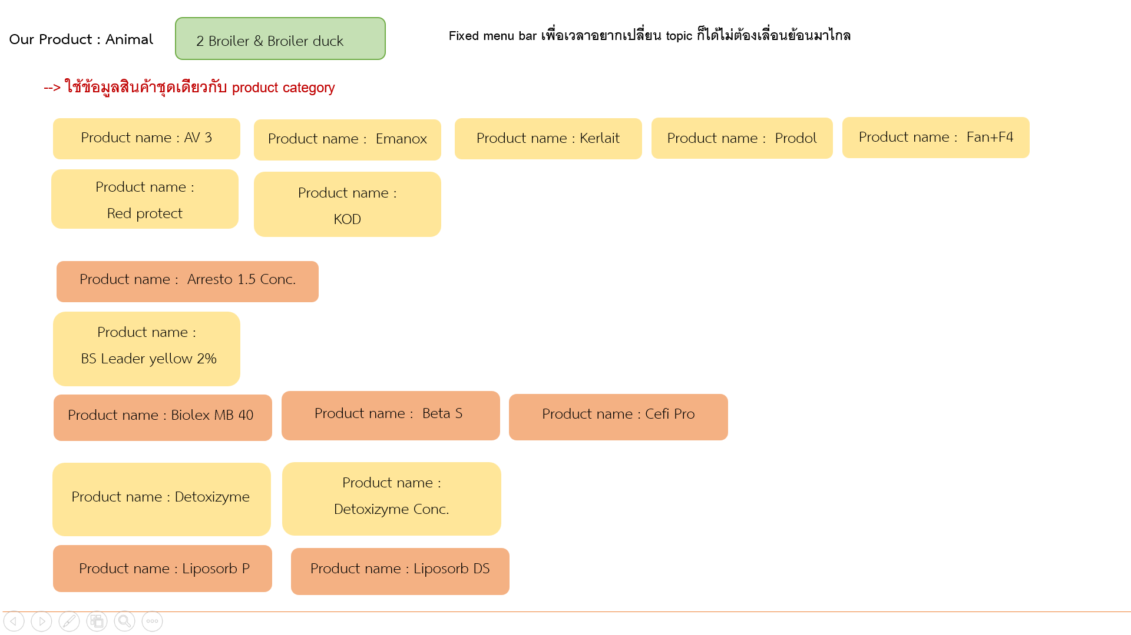

**AV 3**

**Emanox**

**Kerlait**

**Prodol**

**Fan+F4**

**Red protect**

**KOD**

Arresto 1.5 Conc.

**BS Leader yellow 2%**

Biolex MB 40

Beta S

Cefi Pro

**Detoxizyme**

**Detoxizyme Conc.**

Liposorb P

Liposorb DS

**Our Product : Animal 3. Swine**

**Fixed menu bar เพื่อเวลาอยากเปลี่ยน topic ก็ได้ไม่ต้องเลื่อนย้อนมาไกล**

**--> ใช้ข้อมูลสินค้าชุดเดียวกับ product category**

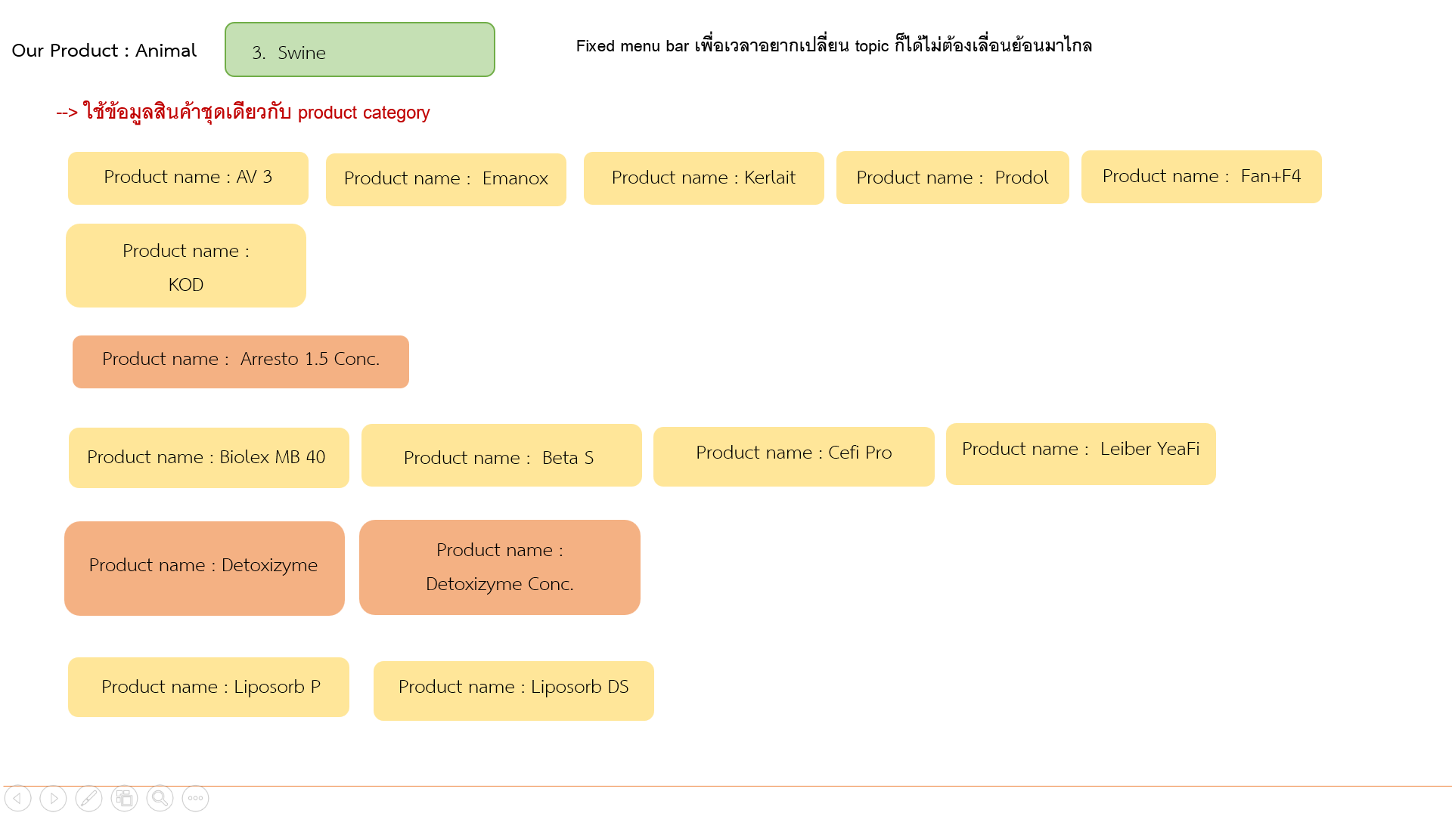

**AV 3**

**Emanox**

**Kerlait**

**Prodol**

**Fan+F4**

**KOD**

Arresto 1.5 Conc.

**Biolex MB 40**

**Beta S**

**Cefi Pro**

**Leiber YeaFi**

Detoxizyme

Detoxizyme Conc.

**Liposorb P**

**Liposorb DS**

**Our Product : Animal 4. Ruminant**

**Fixed menu bar เพื่อเวลาอยากเปลี่ยน topic ก็ได้ไม่ต้องเลื่อนย้อนมาไกล**

**--> ใช้ข้อมูลสินค้าชุดเดียวกับ product category**

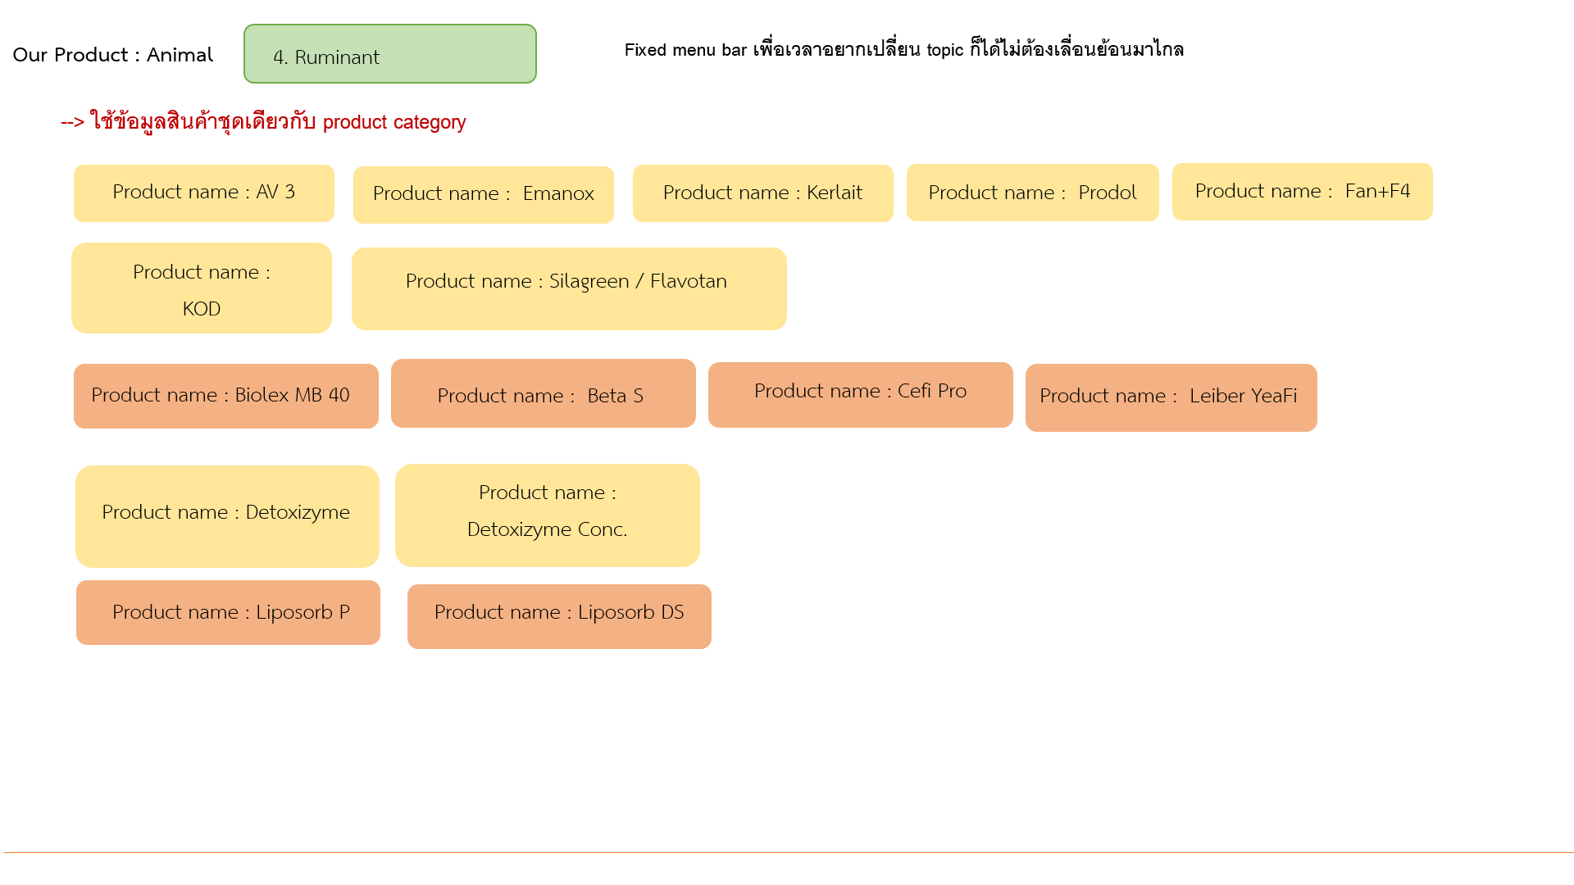

**AV 3**

**Emanox**

**Kerlait**

**Prodol**

**Fan+F4**

**KOD**

**Silagreen / Flavotan**

Biolex MB 40

Beta S

Cefi Pro

Leiber YeaFi

**Detoxizyme**

**Detoxizyme Conc.**

Liposorb P

Liposorb DS

**Our Product : Animal 5. Aquaculture (Shrimp & Fish)**

**Fixed menu bar เพื่อเวลาอยากเปลี่ยน topic ก็ได้ไม่ต้องเลื่อนย้อนมาไกล**

**--> ใช้ข้อมูลสินค้าชุดเดียวกับ product category**  
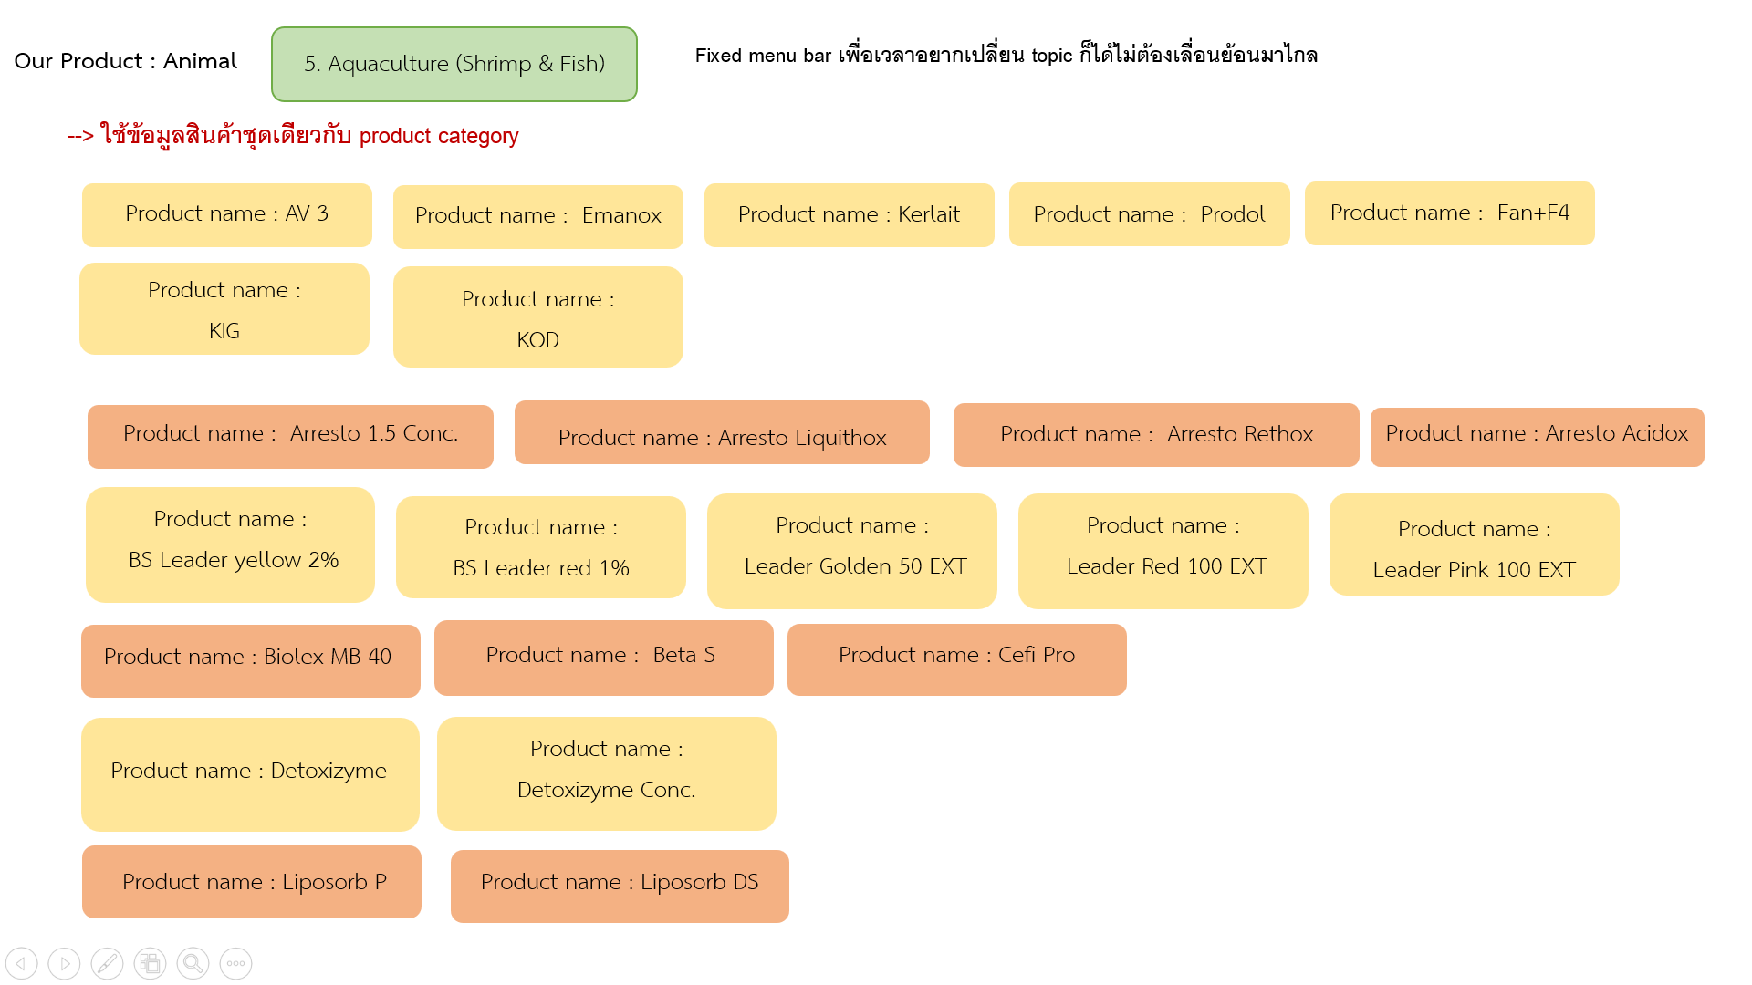

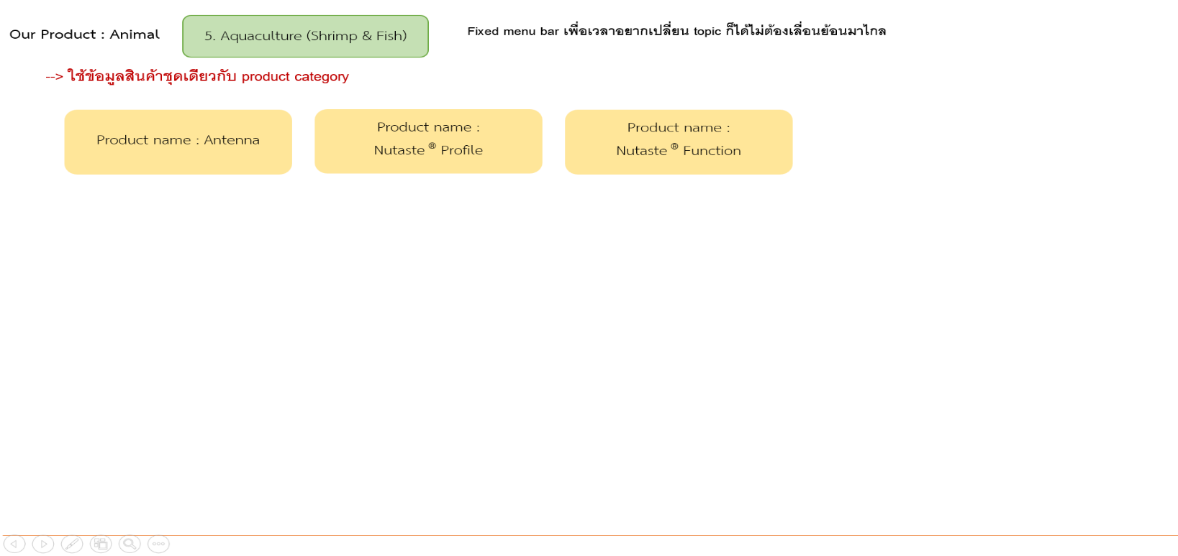

**AV 3**

**Emanox**

**Kerlait**

**Prodol**

**Fan+F4**

**KIG**

**KOD**

Arresto 1.5 Conc.

Arresto Liquithox

Arresto Rethox

Arresto Acidox

**BS Leader yellow 2%**

**BS Leader red 1%**

**Leader Golden 50 EXT**

**Leader Red 100 EXT**

**Leader Pink 100 EXT**

Biolex MB 40

Beta S

Cefi Pro

**Detoxizyme**

**Detoxizyme Conc.**

Liposorb P

Liposorb DS

**Antenna**

**Nutaste ® Profile**

**Nutaste ® Function**

**Our Product : Animal 6.Pet**

**Fixed menu bar เพื่อเวลาอยากเปลี่ยน topic ก็ได้ไม่ต้องเลื่อนย้อนมาไกล**

**--> ใช้ข้อมูลสินค้าชุดเดียวกับ product category**

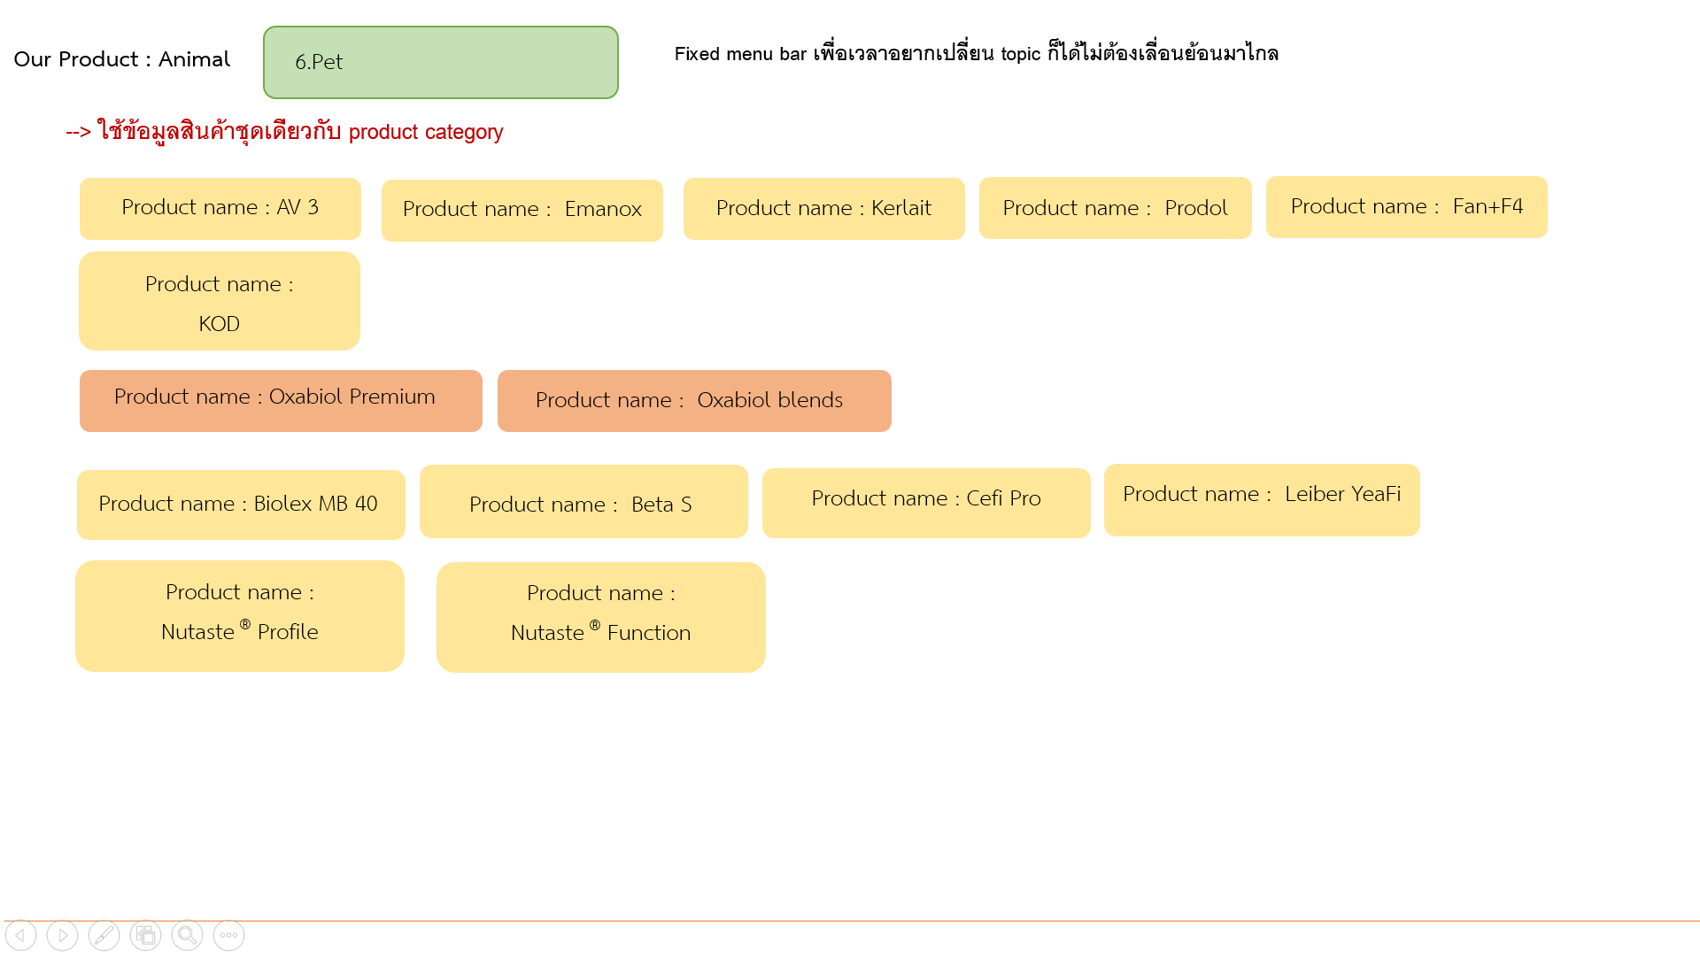

**AV 3**

**Emanox**

**Kerlait**

**Prodol**

**Fan+F4**

**KOD**

Oxabiol Premium

Oxabiol blends

**Biolex MB 40**

**Beta S**

**Cefi Pro**

**Leiber YeaFi**

**Nutaste ® Profile**

**Nutaste ® Function**